**Assignment Day 10**

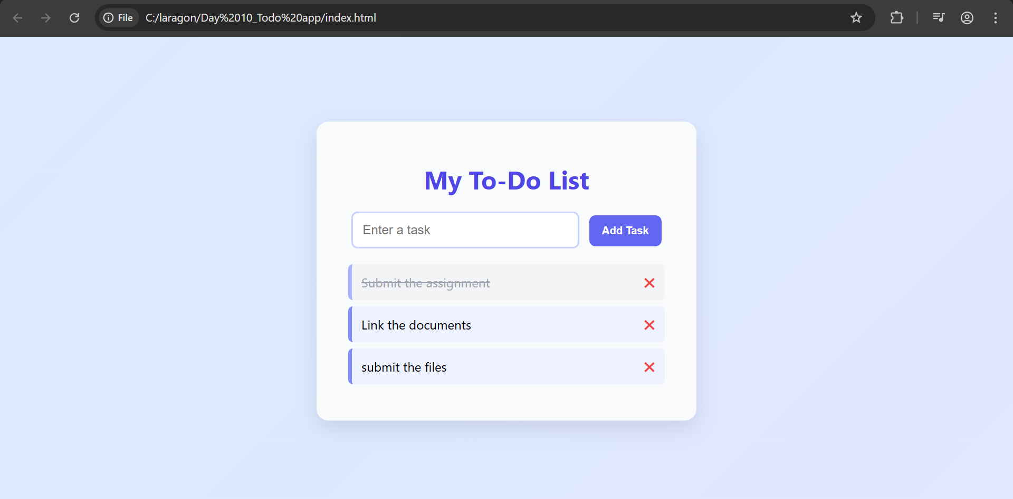

A functional and styled To-Do List web application using HTML, CSS, and JavaScript. I began by building the basic structure with HTML, which included a heading, an input box for typing tasks, an "Add Task" button, and a section to display the list of tasks. Then, I used CSS to style the application with a modern and clean look using soft blue and purple shades. I centered the layout, styled the input field and button, and added visual effects for tasks, including strike-through for completed ones and a delete icon. Finally, I wrote JavaScript to make the app interactive. It allows users to add tasks, mark them as completed with a single click, and remove them with a right-click or by clicking the cross icon. The website is responsive and user-friendly, fulfilling all the assignment requirements.